200 Core Questions from Geeks for Geeks

https://www.geeksforgeeks.org/java-interview-questions/

JVM

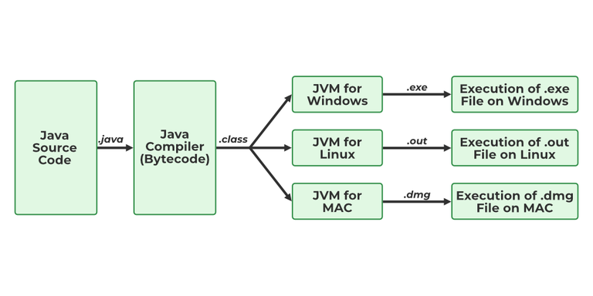

JIT

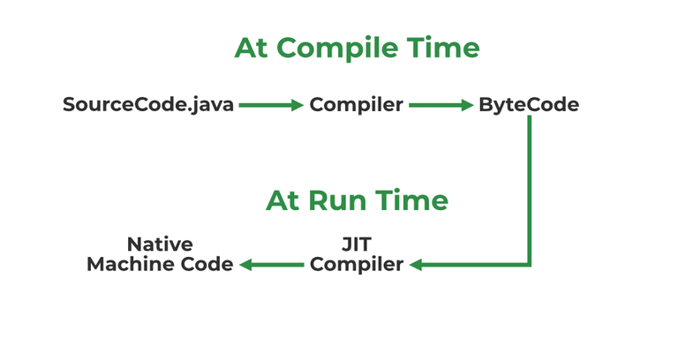

Keywords:

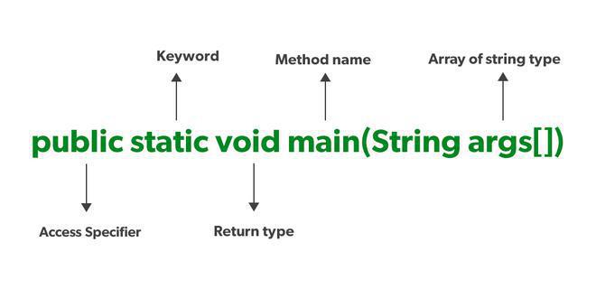

**static**: static is a keyword used so that we can use the element without initiating the class so to avoid the unnecessary allocation of the memory.

### Java String Pool

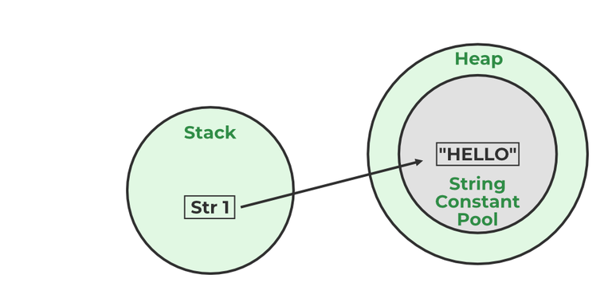

Whenever we create a new string object, JVM checks for the presence of the object in the String pool, If String is available in the pool, the same object reference is shared with the variable, else a new object is created.

Packages avoid name clashes.

The Package provides easier access control.

We can also have the hidden classes that are not visible outside and are used by the package.

Primitive Data Type

Non-Primitive Data Type or Object Data type

* **boolean**: stores value true or false
* **byte**: stores an 8-bit signed two’s complement integer
* **char**: stores a single 16-bit Unicode character
* **short**: stores a 16-bit signed two’s complement integer
* **int**: stores a 32-bit signed two’s complement integer
* **long**: stores a 64-bit two’s complement integer
* **float**: stores a single-precision 32-bit IEEE 754 floating-point

1. **double**: stores a double-precision 64-bit IEEE 754 floating-point

Non-Primitive are mentioned below:

* Strings
* Array
* Class
* Object
* Interface

the wrapper class is an object class that encapsulates the primitive data types.

1. Wrapper classes are final and immutable
2. Provides methods like valueOf(), parseInt(), etc.
3. It provides the feature of autoboxing and unboxing.

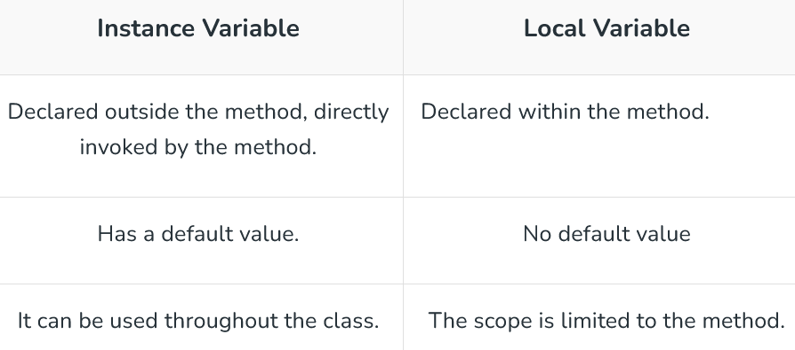

a class variable (also known as a static variable) is a variable that is declared within a class but outside of any method, constructor, or block.

**System.out –** It is a PrintStream that is used for writing characters or can be said it can output the data

IO Stream



All the stream classes can be divided into two types of classes that are ByteStream classes and CharacterStream Classes. The ByteStream classes are further divided into InputStream classes and OutputStream classes. CharacterStream classes are also divided into Reader classes and Writer classes. The SuperMost classes for all the InputStream classes is java.io.InputStream and for all the output stream classes is java.io.OutPutStream. Similarly, for all the reader classes, the super-most class is java.io.Reader, and for all the writer classes, it is java.io.Writer.

// Java Program to demonstrate Reading Writing Binary Data

// with InputStream/OutputStream

import java.io.*;

class GFG {

public static void main(String[] args) {

try {

// Writing binary data to a file using OutputStream

byte[] data = {(byte) 0xe0, 0x4f, (byte) 0xd0, 0x20, (byte) 0xea};

OutputStream os = new FileOutputStream("data.bin");

os.write(data);

os.close();

// Reading binary data from a file using InputStream

InputStream is = new FileInputStream("data.bin");

byte[] newData = new byte[5];

is.read(newData);

is.close();

// Printing the read data

for (byte b : newData) {

System.out.println(b);

}

} catch (IOException e) {

e.printStackTrace();

}

}

}

**FileInputStream** in Java is used to read data from a file as a stream of bytes. It is mostly used for reading binary data such as images, audio files, or serialized objects.

Buffering allows programs to write a big amount of data instead of writing it in small chunks.

**Filter Streams** returns a stream consisting of the elements of this stream that match the given predicate.

All types of operators in Java are mentioned below:

1. Arithmetic Operators
2. Unary Operators
3. Assignment Operator
4. Relational Operators
5. Logical Operators
6. Ternary Operator
7. Bitwise Operators
8. Shift Operators
9. instance of operator

transient keyword is used at the time of serialization if we don’t want to save the value of a particular variable in a file.

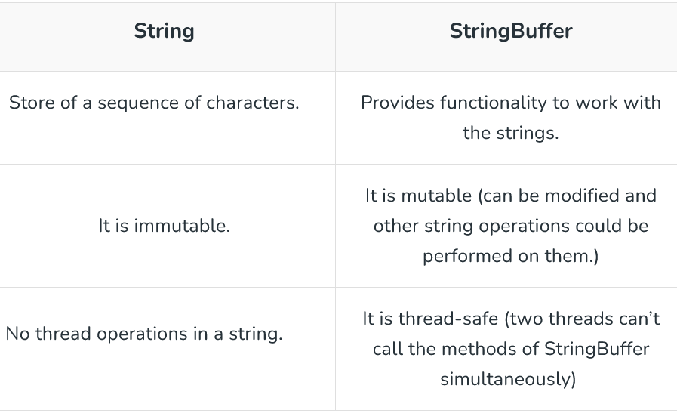

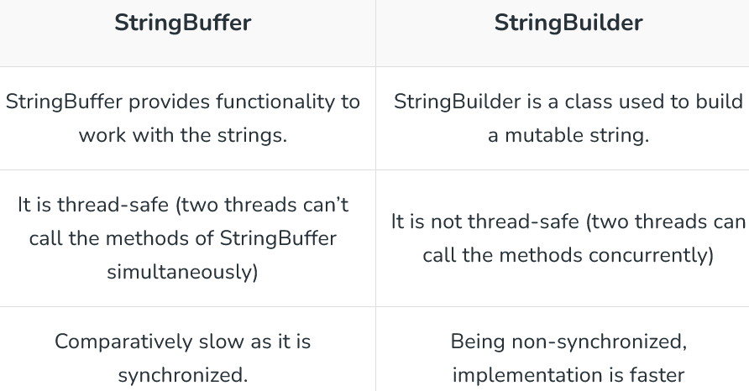

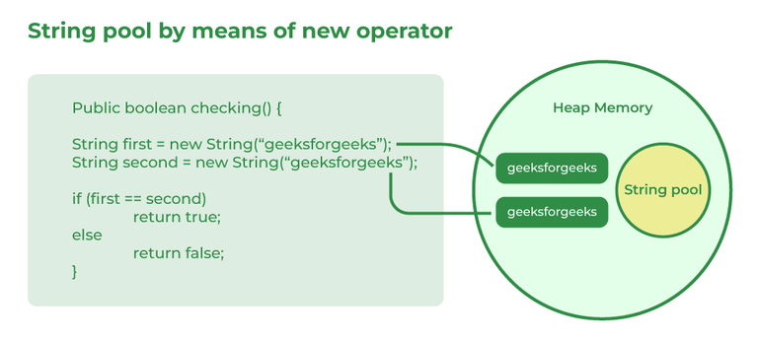A

using new() it allocates a dynamic memory in the heap memory.

Аrray in Java is a data structure that is used to store a fixed-size sequence of elements of the same type.

Arrays in Java are created in heap memory.

to copy Array:

tempArr = Arr.clone();

System.arraycopy(Arr, 0, tempArr, 0, Arr.length);

tempArr = Arrays.copyOf(Arr, Arr.length);

jagged Array in Java is just a two-dimensional array in which each row of the array can have a different length.

Volatile keywords in Java can only be applied to individual variables but not to arrays or collections. The value of the Variable is always read from and written to the main memory when it is defined as volatile rather than being cached in a thread’s local memory.

main concepts of OOPs in Java are mentioned below:

* Inheritance
* Polymorphism
* Abstraction
* Encapsulation

object is a real-life entity that has certain properties and methods associated with it.

In Java, Classes are the collection of objects sharing similar characteristics and attributes. Classes represent the blueprint or template from which objects are created.

to create objects in Java are mentioned below:

1. Using new keyword
2. Using new instance
3. Using clone() method
4. Using deserialization
5. Using the newInstance()

Constructor is a special method that is used to initialize objects.

private constructor is used if you don’t want any other class to instantiate the object to avoid subclassing.

interface in Java is a collection of static final variables and abstract methods that define the contract or agreement for a set of linked classes.

Interface in Java programming language is defined as an abstract type used to specify the behavior of a class. An interface in Java is a blueprint of a behavior.

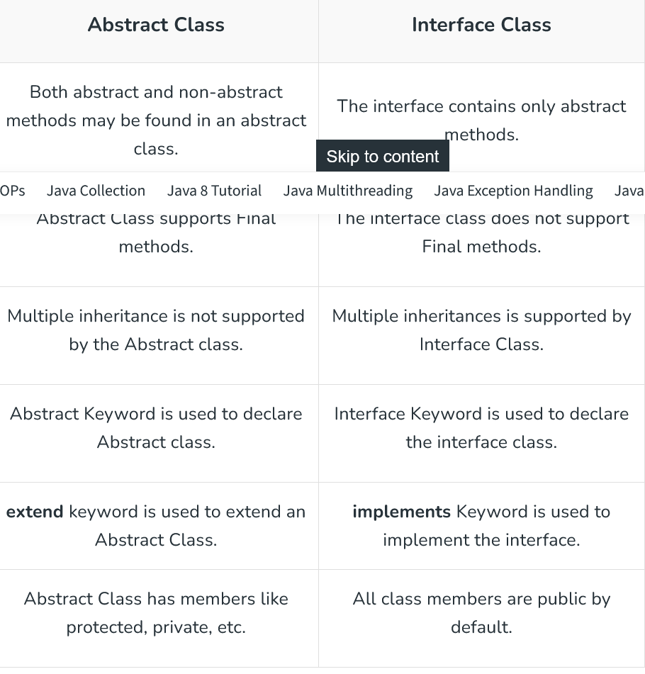

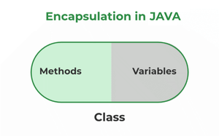

The advantages of Encapsulation in Java are mentioned below:

1. Data Hiding:  it is a way of restricting the access of our data members by hiding the implementation details. Encapsulation also provides a way for data hiding. The user will have no idea about the inner implementation of the class.
2. Increased Flexibility: We can make the variables of the class read-only or write-only depending on our requirements.
3. Reusability: Encapsulation also improves the re-usability and is easy to change with new requirements.
4. Testing code is easy: Code is made easy to test for unit testing.

main advantage of Encapsulation in Java is its ability to protect the internal state of an object from external modification or access.

Aggregation is a term related to the relationship between two classes best described as a “has-a” relationship.

‘IS-A’ is a type of relationship in OOPs Java where one class inherits another class.

When an object that belongs to a subclass acquires all the properties and behavior of a parent object that is from the superclass, it is known as inheritance.

Composition is a restricted form of Aggregation in which two entities are highly dependent on each other. It represents **part-of** the relationship.

Polymorphism is defined as the ability to take more than one form It is of two types namely, Compile time polymorphism or method overloading- a function called during compile time.

static methods are part of the class rather than the object so we can’t override them.